

**School of Engineering and Technology**

**Internet of Things**

*(Practical File)*

**18BCS-0IT32L**

***Submitted To:***

***Submitted By:***

Name: Parth Singh

Roll Number: 170BTCCSE020

Branch: Computer Science and Engg.

Year/Sem: 3rd Year – 6th Semester

Faculty: Mr. Antim Dev Mishra

Experiment 2

**Aim:** Write a program to test actuators

**Apparatus:**

* Arduino UNO
* Servo Motor

**Theory:**

**Arduino UNO**

The Arduino Uno is a microcontroller board based on the ATmega328. It has 14 digital input/output pins (of which six can be used as PWM outputs), six analog inputs, a 16 MHz crystal oscillator, a USB connection, a power jack, an ICSP header, and a reset button. It contains everything needed to support the microcontroller; simply connect it to a computer with a USB cable or power it with an AC-to-DC adapter or battery to get started.

The Arduino Uno differs from all preceding boards because it does not use the FTDI USB-to-serial driver chip. Instead, it features the ATmega8U2 programmed as a USB-to-serial converter. Revision 2 of the Arduino Uno board has a resistor pulling the 8U2 HWB line to ground, making it easier to put into DFU mode.

|  |  |
| --- | --- |
| **Features** |  |
| * 14 digital I/O pins (six of which provide PWM output) * 3.3 V supply generated by an on-board regulator * Six analog input pins * 32 KB of flash memory | * Can supply 40 mA of DC current per pin * 16 MHz clock speed * Code example from Arduino website to help get started |

**Servo Motor**

A servo motor is an electrical device which can push or rotate an object with great precision. If you want to rotate and object at some specific angles or distance, then you use servo motor. It is just made up of simple motor which run through servo mechanism. If motor is used is DC powered then it is called DC servo motor, and if it is AC powered motor then it is called AC servo motor. We can get a very high torque servo motor in a small and light weight packages. Doe to these features they are being used in many applications like toy car, RC helicopters and planes, Robotics, Machine etc.

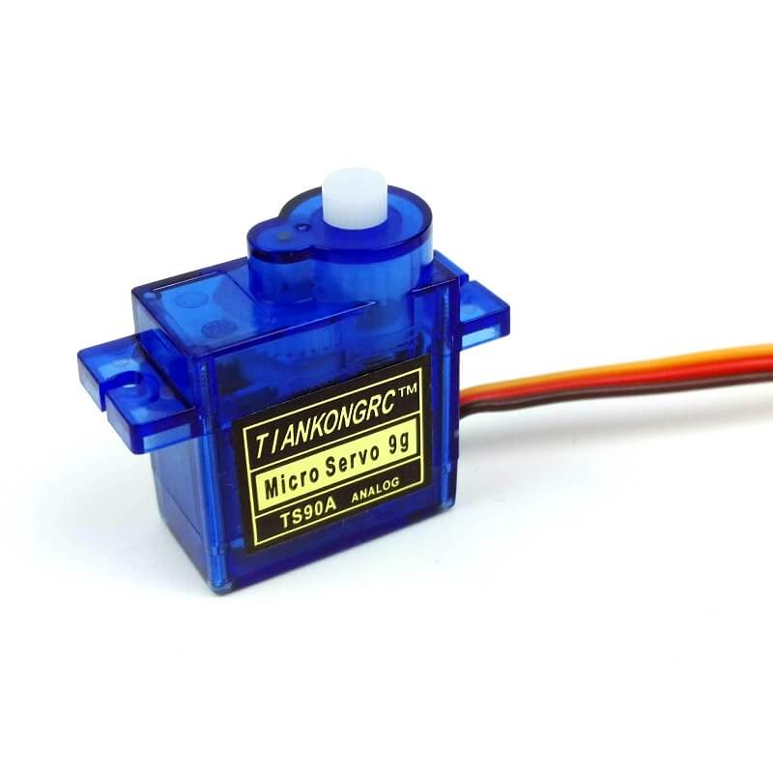

It consists of three parts:

1. Controlled device
2. Output Sensor
3. Feedback system

It is a closed loop system where it uses positive feedback system to control motion and final position of the shaft. Here the device is controlled by a feedback signal generated by comparing output signal and reference input signal.

**Circuit Diagram:**

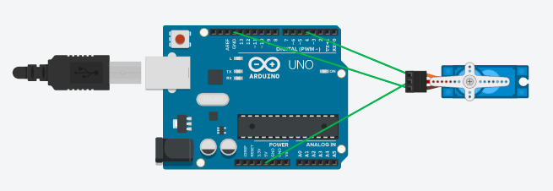

**Code:**

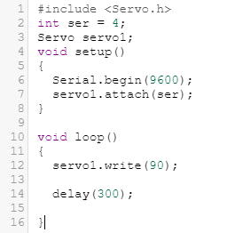

**Result:**

